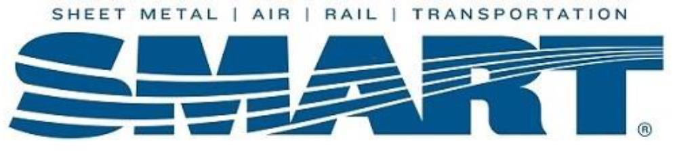
ATTENTION ALL MEMBERS
HERE ARE THE RESULTS FROM OUR ELECTION THAT WAS HELD ON 7/23/2016.
TOTAL BALLOTS RETURNED – 915
BALLOTS NOT COUNTED – 47
TOTAL ELECTION RESULTS:
YES – 545
NO – 322

SECRETARY LOCAL #0060
MARC F. SUSSMAN

